**10 - Understanding Imports Sets in ServiceNow**

Import sets allow administrators to bring data from various sources into ServiceNow tables.Data can come from sources like spreadsheets, web services, or JDBC connections. This data is first imported into an import set table, which acts as an intermediary before it gets mapped to ServiceNow tables.

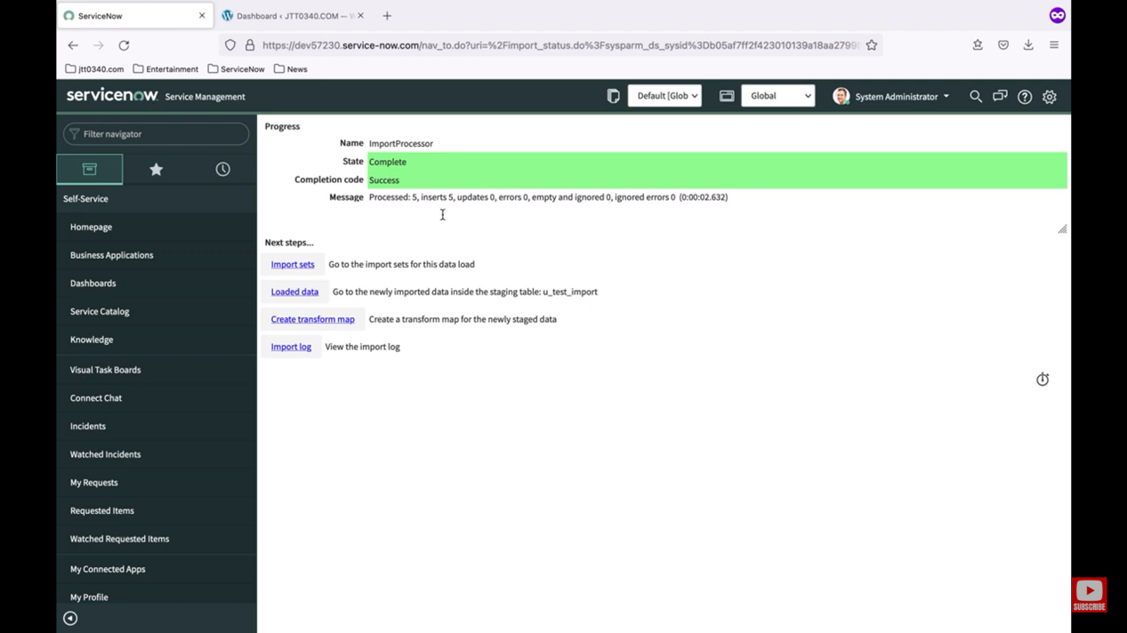

The transform map's job is to clean and organize the raw data from the sources. If a row in the spreadsheet matches an existing record in ServiceNow, that record is updated. If it doesn't match, a new record is created. When multiple fields are set to coalesce (coalesce), all those fields must match for an update to occur.

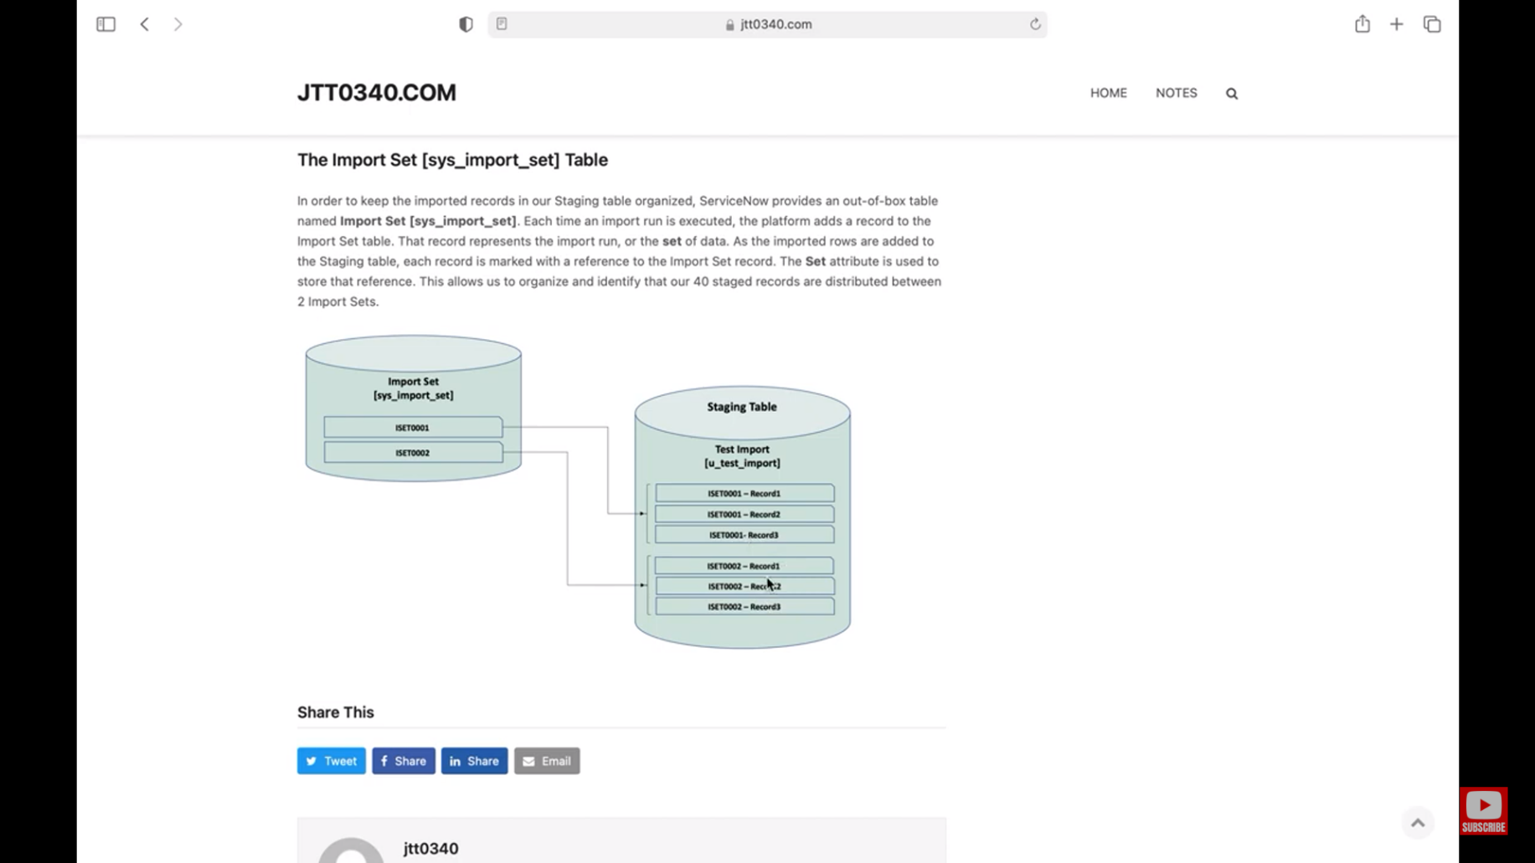

ANANYA CHOUDHARY